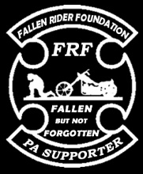**Fallen Riders Foundation / Central PA Chapter**

Email: riders@wardrivers.org

Phone: (814) 251- 5894

Fallen Riders Foundation

A 501(C) nonprofit corporation certified as a public charity

**Meeting Minutes for Fallen Rider Foundation Central PA Chapter**

Location- Date- Time-

President:

Secretary Report:

Reading or waiving of last meetings minutes

Motion to accept:

2nd by:

Treasurer Report: Julie Levering

Beginning balance: FRF:

Warchest:

Ending balance:

Motion to accept:

2nd by:

Vice President Report: Scott Levering

Liaison Report: Chris Hurley

Public Relations: Kathy Hurley

Sargent of Arms Report: Don Hamer, Jeremy Rhodes, Toby Delemarter

Road Captain: Deron French, George Marks

Small Games Officer: Shawna Leahy

Chaplain; Dan Leahy



National Updates:

Fallen Rider updates:

Old business:

New business:

Business supporters:

* Hotel Wayne, McVeytown
* Hurley’s Garage, McVeytown

Meetings/Events:

Membership votes:

Agenda for next meeting:

Motion to adjourn: Time

Motion:

2nd by:

Attendance: